Alex Arnold
Professor Torres
Date you turned it in
IT 0115-41197
Lab 01

Part A:
- Research Server Administrator jobs on the internet.
  - What education requirements are needed?
      - Bachelor’s degree, or equivalent combination of experience/training, in one or more of the following fields: computer science, engineering, computer information systems, etc.
      - Two year technical degree or higher

  - What job duties/roles do Server/System Administrators perform?
      - application hosting, productivity tools, cybersecurity infrastructure support, and second-level technical assistance.
      - Produces system upgrade roadmaps for assigned technology platform(s) and executing plans.
      - Monitors System backups, performs data restores and performs troubleshooting as needed.
      - Monitors the compliance to the enterprise's security policies
      - Writes documentation manuals and procedure manuals and keeps track of updates to these documents
      - Provides support by responding to network problems issued from the Help Desk

  - What certifications or credentials are needed for these roles/jobs?
      - CompTIA security +
      - AWS Certified Cloud Practitioner – Foundational
      - Server Certification (Microsoft, RedHat)
      - VMware Certified Professional (VCP) or equivalent
  - Do you believe that this class will provide you with everything that you need for these roles/jobs?

      - No I do not as some of the jobs will require further training or further certifications that this class does not explicitly provide. Most jobs will also require some form of specialized or specific training / knowledge that is unique to their environment.

  - What do you expect to get out of this class?
      - From this class I expect to get a foundational understanding of server system administration. Hopefully this will help me to further progress on to the higher level courser required for the associates degrees that I am looking to gain.

Part B: Netlab EnvironmentLinks to an external site.
- Log on to Netlab (MCSA-70-740) and launch Configure Windows Server 2016
Log on to all systems
Systems in the lab are as follows
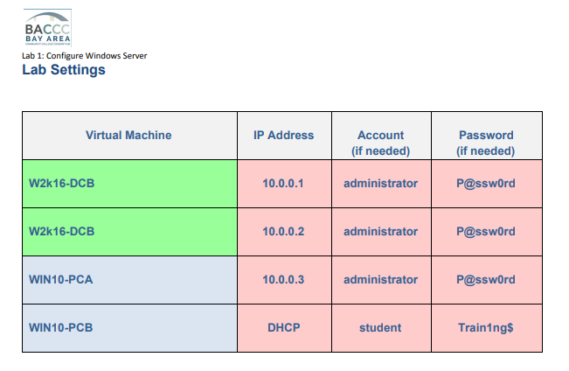
Un-dock one of the Windows Servers
- Undocking is accomplished by clicking on the upper left tab of the computer you would like to undock and then clinking on undock in the menu (as seen below)
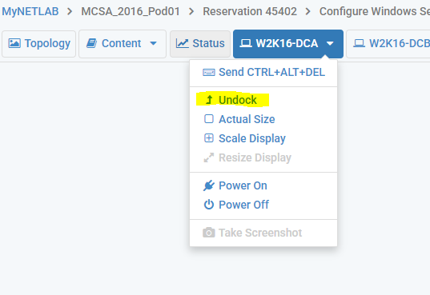
- Below is an image of what an undocked computers window will look like.
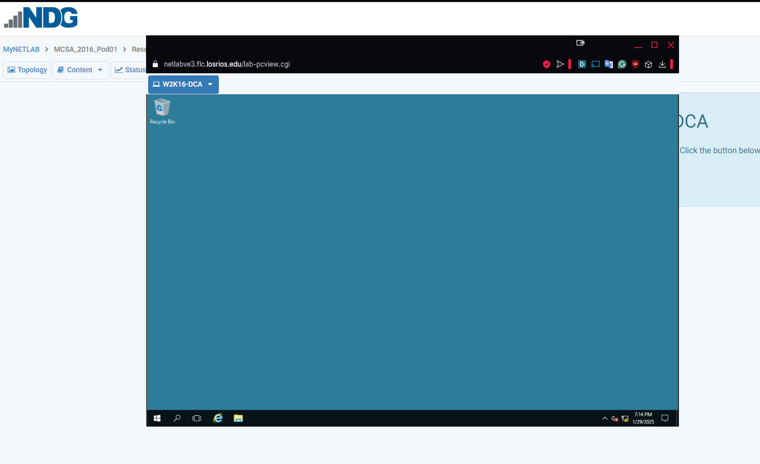

From each system, ping all other systems to ensure that you can reach everything
- To accomplish this we need the ip address of each system
  - W2K16-DCA
    - Eth0 10.0.0.1
    - intel virtual switch 169.254.119.24
    - Eth1 192.168.0.1
  - W2K16-DCB
    - Internal nic 172.29.192.1
    - Eth0 10.0.0.2
  - WIN10-A
    - Eth3 10.0.0.3
  - WIN10-B
    - 169.254.150.135

- After this we can ping from each device to all other devices
  - W2K16-DCA
    - W2K16-DCB
      - Internal nic 172.29.192.1 (unreachable)
      - Eth0 10.0.0.2 (Success)
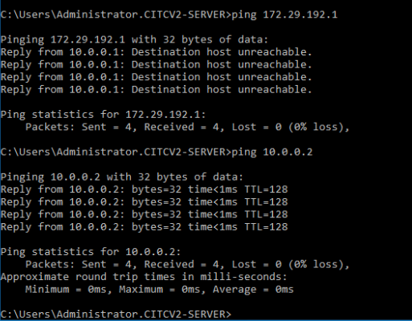
    - WIN10-A
      - Eth3 10.0.0.3 (Success)
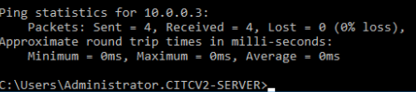
    - WIN10-B
      - 169.254.150.135 (Success)
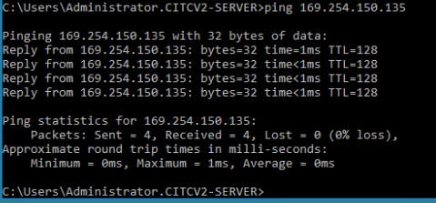

  - W2K16-DCB
    - W2K16-DCA
      - Eth0 10.0.0.1 (Success)
      - intel virtual switch 169.254.119.24 (unreachable)
      - Eth1 192.168.0.1 (unreachable)
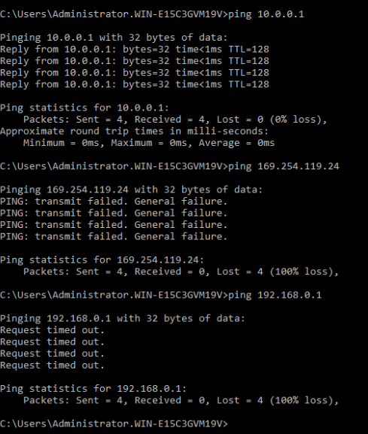
    - WIN10-A
      - Eth3 10.0.0.3 (Success)
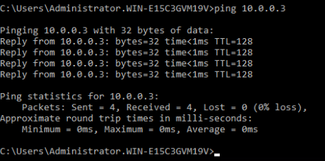
    - WIN10-B
      - 169.254.150.135 (unreachable)
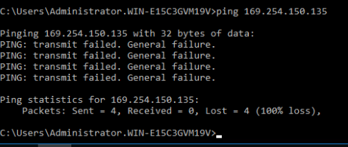

  - WIN10-A
    - W2K16-DCA
      - Eth0 10.0.0.1 (Success)
      - intel virtual switch 169.254.119.24 (unreachable)
      - Eth1 192.168.0.1 (unreachable)
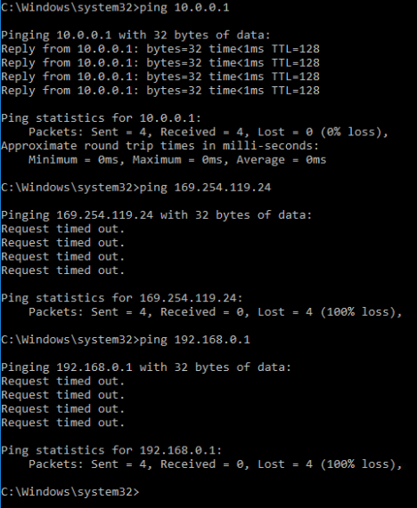
    - W2K16-DCB
      - Internal nic 172.29.192.1 (unreachable)
      - Eth0 10.0.0.2 (Success)
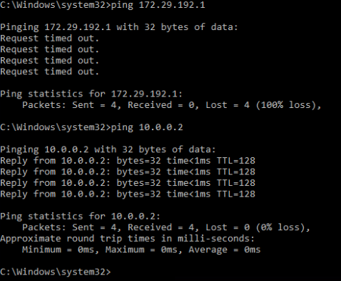
    - WIN10-B
      - 169.254.150.135 (unreachable)
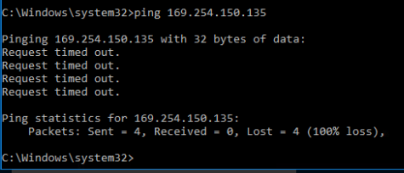

  - WIN10-B
    - W2K16-DCA
      - Eth0 10.0.0.1 (unreachable)
      - intel virtual switch 169.254.119.24 (Success)
      - Eth1 192.168.0.1 (unreachable)
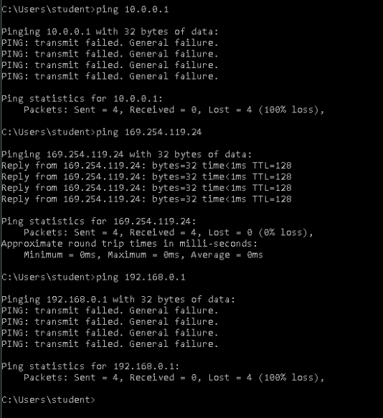
    - W2K16-DCB
      - Internal nic 172.29.192.1 (unreachable)
      - Eth0 10.0.0.2 (unreachable)
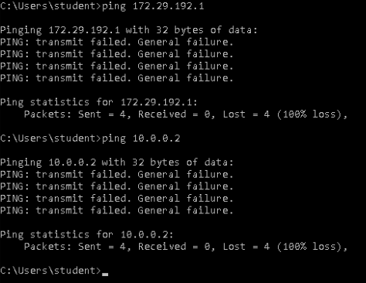
    - WIN10-A
      - Eth3 10.0.0.3 (unreachable)
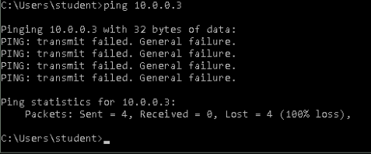

- With these results we can see which devices can talk to each other
  - W2K16-DCA (10.0.0.1 | 169.254.119.24 | 192.168.0.1)
    - W2K16-DCB – connected
    - WIN10-A – connected
    - WIN10-B – connected
  - W2K16-DCB (172.29.129.1 | 10.0.0.2)
    - W2K16-DCA – connected
    - WIN10-A – connected
    - WIN10-B – unreachable
  - WIN10-A (10.0.0.3)
    - W2K16-DCA – connected
    - W2K16-DCB – connected
    - WIN10-B – unreachable
  - WIN10-B (169.254.150.135)
    - W2K16-DCA – connected
    - W2K16-DCB – unreachable
    - WIN10-A – unreachable

- The reason that the devices can’t talk to each other is that they are on some networks and not others. This then makes them physically unable to establish a connection with each other in some cases.

Part C:
- What was the most important topic for you in the intro lecture?
  - The most important topic for me in the lecture was the discussion on how the labs will be done and what the expectations are from us in creating our documents for the lab assignments. Without this I would have missed key expectations and understanding as to what the expectations are.

